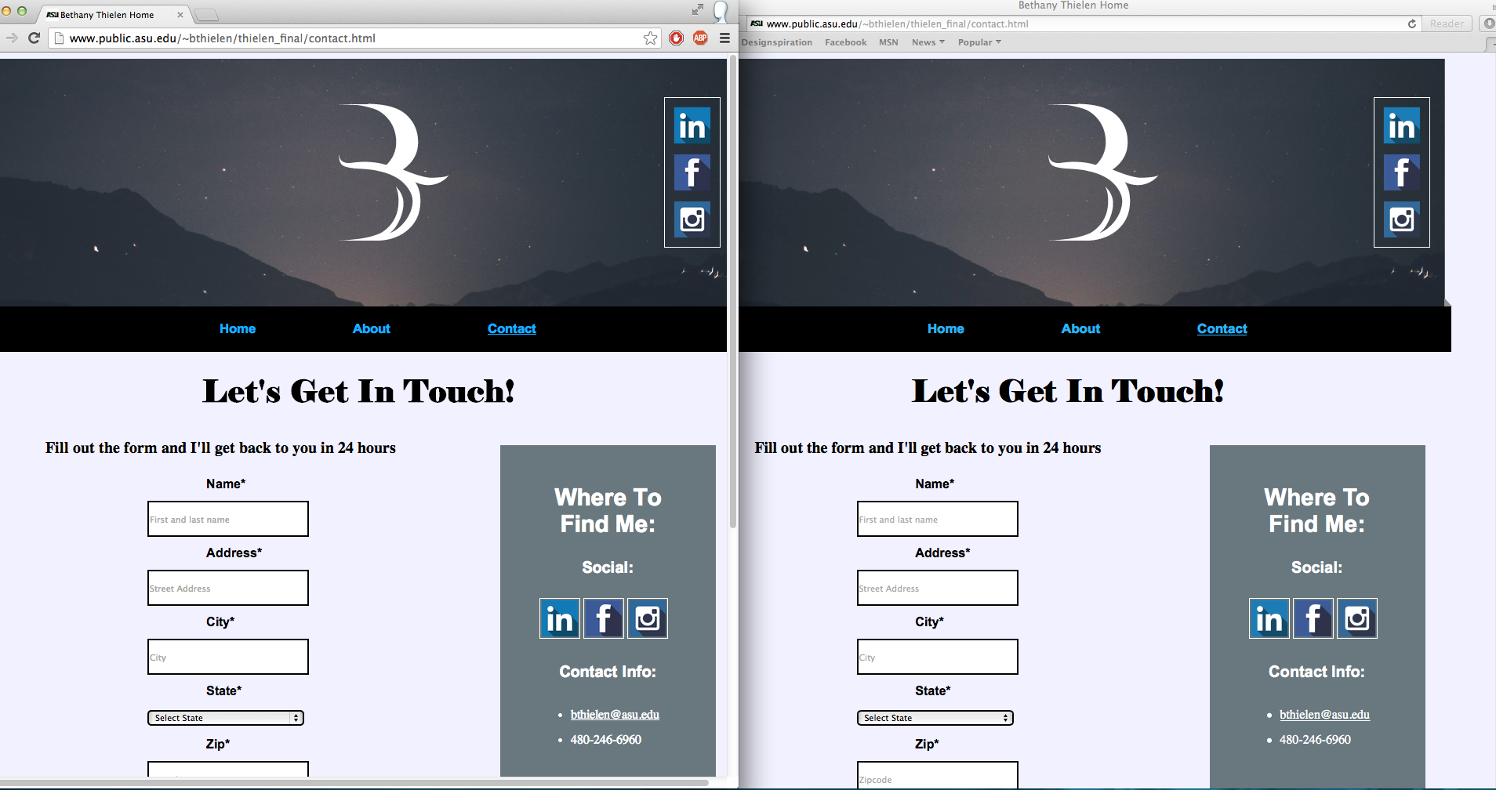

Comparing the two, there was absolutely no noticeable difference that I was able to find. The only difference shown in the screenshot is how much of the screen is displayed and that was due to a slight unevenness in the size of the browser windows.